## VISVESVARAYA TECHNOLOGICAL UNIVERSITY

**“JnanaSangama”, Belgaum -590014, Karnataka.**



**PROJECT WORK-1 REPORT**

**on**

**COLLEGE ADMISSION REGISTRATION FORM**

***Submitted by***

**NIKHIL S.N (1BM19CS102)**

**NITISH KUMAR M(1BM19CS107)**

**P PREM SAI (1BM19CS109)**

***Under the Guidance of***

|  |  |
| --- | --- |
| **Dr. Bhoomika A P**  **Associate Professor, BMSCE** |  |

***in partial fulfillment for the award of the degree of***

**BACHELOR OF ENGINEERING**

***in***

**COMPUTER SCIENCE AND ENGINEERING**



**B.M.S. COLLEGE OF ENGINEERING**

**(Autonomous Institution under VTU)**

**BENGALURU-560019**

**Sep-2020 to Jan-2021**

**B. M. S. College of Engineering,**

**Bull Temple Road, Bangalore 560019**

(Affiliated To Visvesvaraya Technological University, Belgaum)

**Department of Computer Science and Engineering**



**CERTIFICATE**

This is to certify that the project work entitled “**COLLEGE ADMISSION REGISTRATION FORM**” carried out by **NIKHIL S.N(1BM19CS102), NITISH KUMAR.M (1BM19CS107) AND P PREM SAI(1BM19CS109)** who are bonafide students of **B. M. S. College of Engineering.** It is in partial fulfillment for the award of **Bachelor of Engineering in Computer Science and Engineering** of the Visveswaraiah Technological University, Belgaum during the year 2020-2021. The project report has been approved as it satisfies the academic requirements in respect of **Project Work-1 (19CS3PWPW1)** work prescribed for the said degree.

Signature of the Guide                 Signature of the HOD

Dr. Bhoomika A P Dr. Umadevi V

Associate Professor Associate Prof.& Head, Dept. of CSE

BMSCE, Bengaluru BMSCE, Bengaluru

External Viva

Name of the Examiner                                                                                       Signature with date

1._____________________________ ________________________

2. _____________________________ _________________________

**B.M.S. College of EngineerinG**

**DEPARTMENT OF COMPUTER SCIENCE AND ENGINEERING**



***DECALARATION***

We, NIKHIL S.N (1BM19CS102), NITISH KUMAR.M (1BM19CS107) and P.PREMSAI (1BM19CS109) students of 3rd Semester, B.E, Department of Computer Science and Engineering ,B. M. S. College of Engineering, Bangalore, hereby declare that, this Project Work-1entitled "COLLEGE ADMISSION REGISTRATION FORM" has been carried out by us under the guidance of Dr. Umadevi V, Associate Professor, Department of CSE, B. M. S. College of Engineering, Bangalore during the academic semester Sep-2020-Jan-2021

We also declare that to the best of our knowledge and belief, the development reported here is not from part of any other report by any other students.

Signature

NIKHIL S. N (1BM19CS102)

NITISH KUMAR .M (1BM19CS107)

P PREM SAI (1BM19CS109)

FLOW CHARTOF

WEBPAGE

LOGIN PAGE

ADMIN STUDENT

ADMIN PAGE FORGOT PASSWORD HOME PAGE FORGOT PASSWORD

KNOW ABOUT REGISTER NOW

BMSCE

STUDENT PERSONAL DETAILS

STUDENT ACADEMICS DETAILS

FAMILY PARTICULARS

REGISTRATION SUCCESSFULL

1.Introduction:

Website development for “College Admission Registration”

This online admission registration supports the following users

a. Student.

b. College admission team.

Functionalities under student login:

1.Can register for admission for college through registration form.

2.Can know more information about the college .

Functionalities for college admission team:

1.Can know about the students who has admitted to college.

2. Number of students in courses can be known.

2.Design layouts: Screen Shots of Webpage

2.1:Student Login webpage

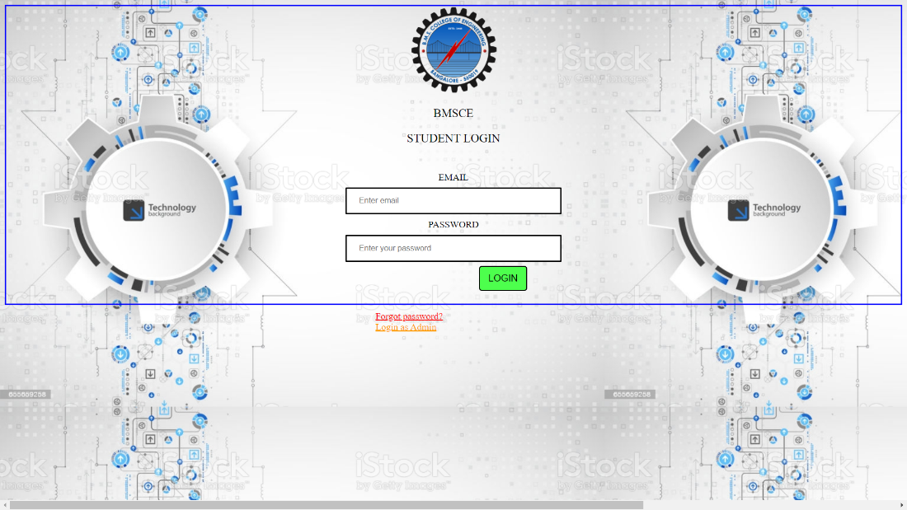

2.2: Student forgot password page

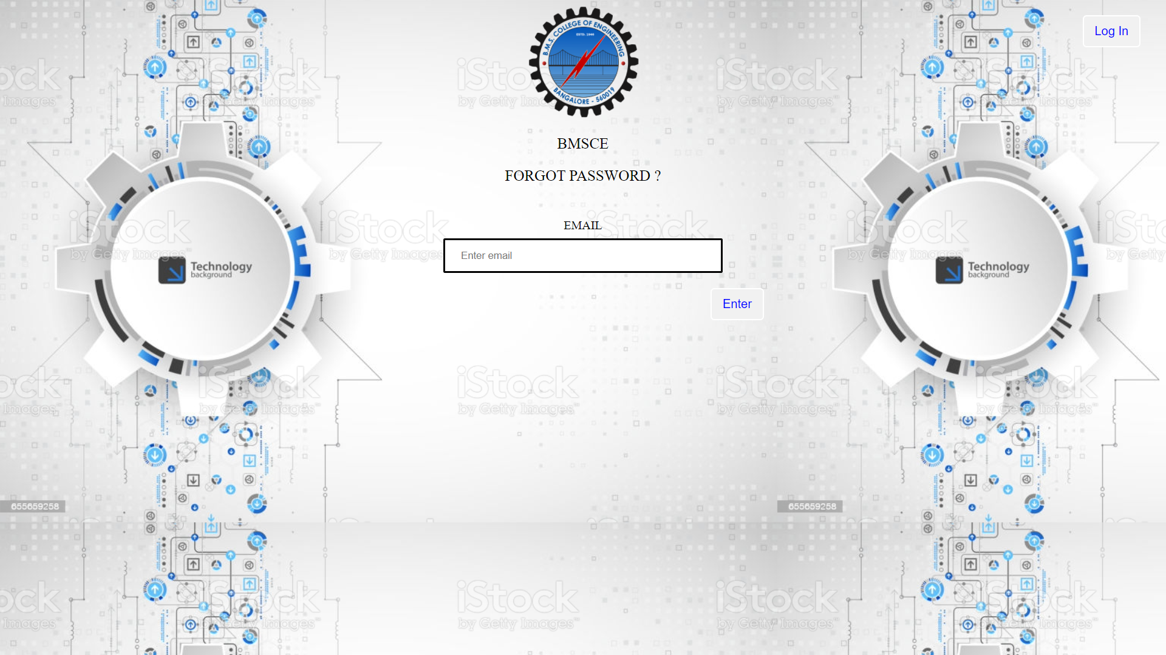

2.3: Home page



2.4: Student Personnel Details page

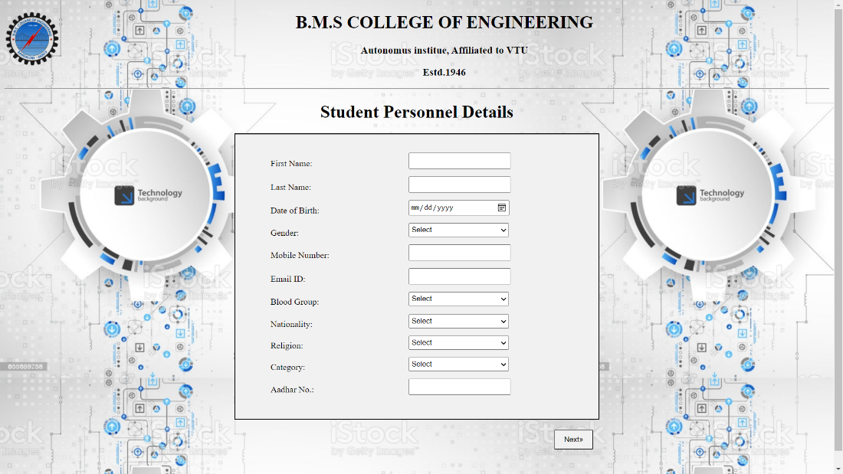

2.5: Student Academic Details page

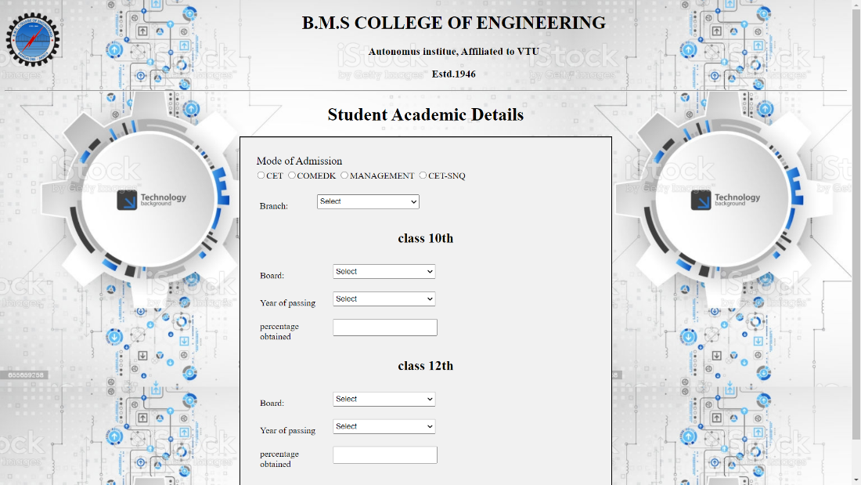

2.6: Family Particulars page

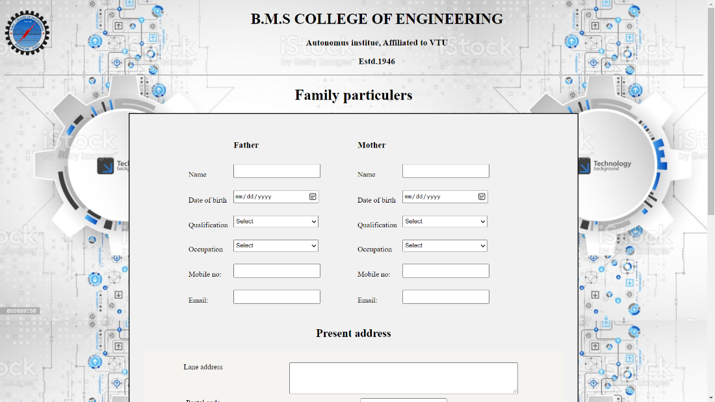

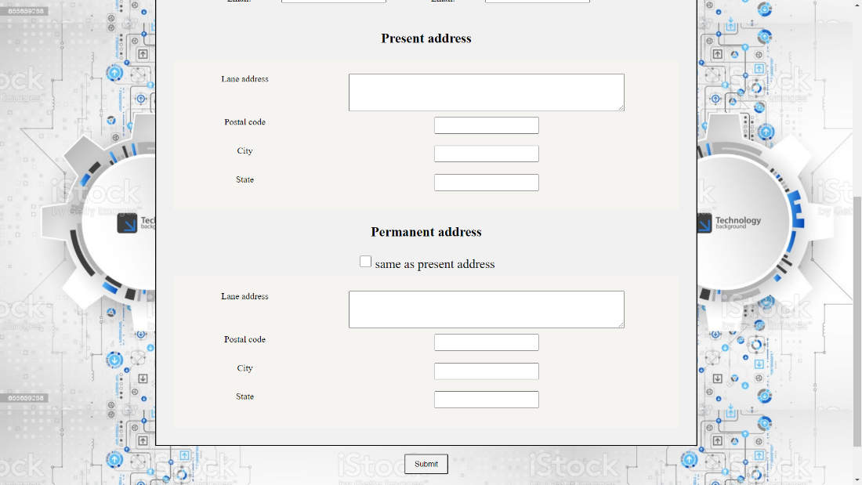

2.7: Registration successful page

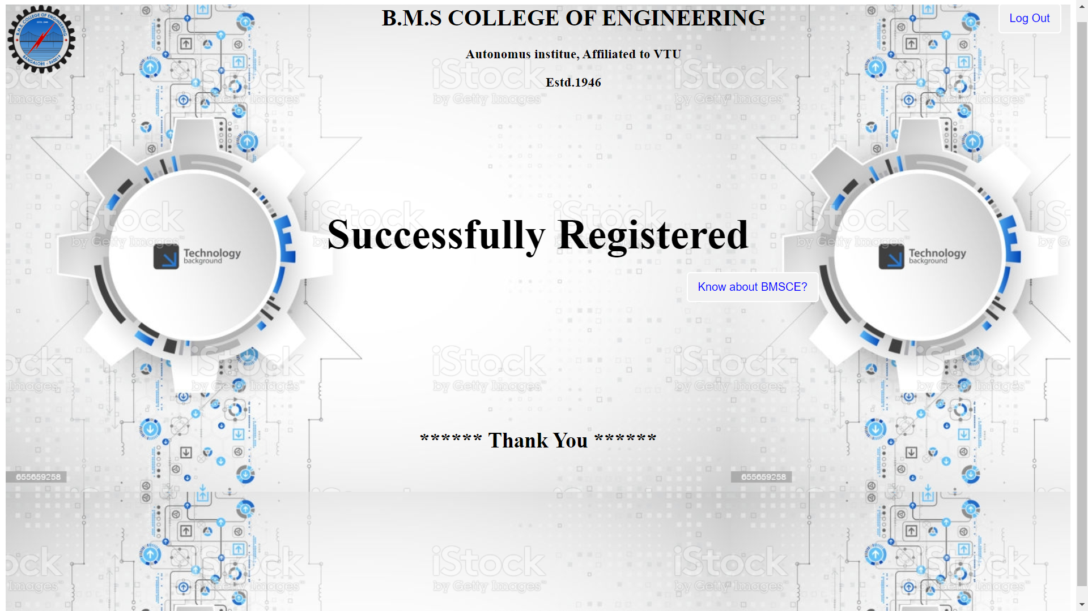

2.8: Admin login page

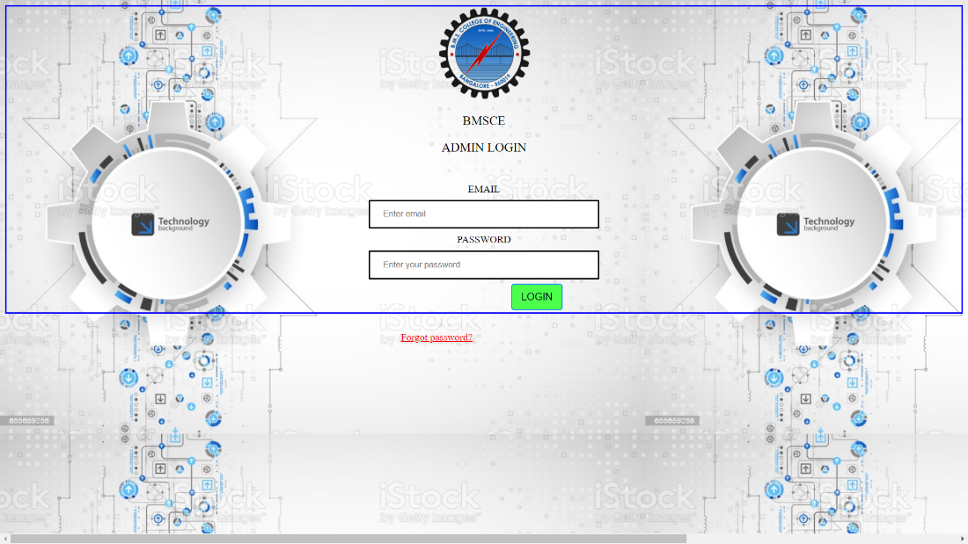

2.9: Admin forgot password page



2.10: Admin page

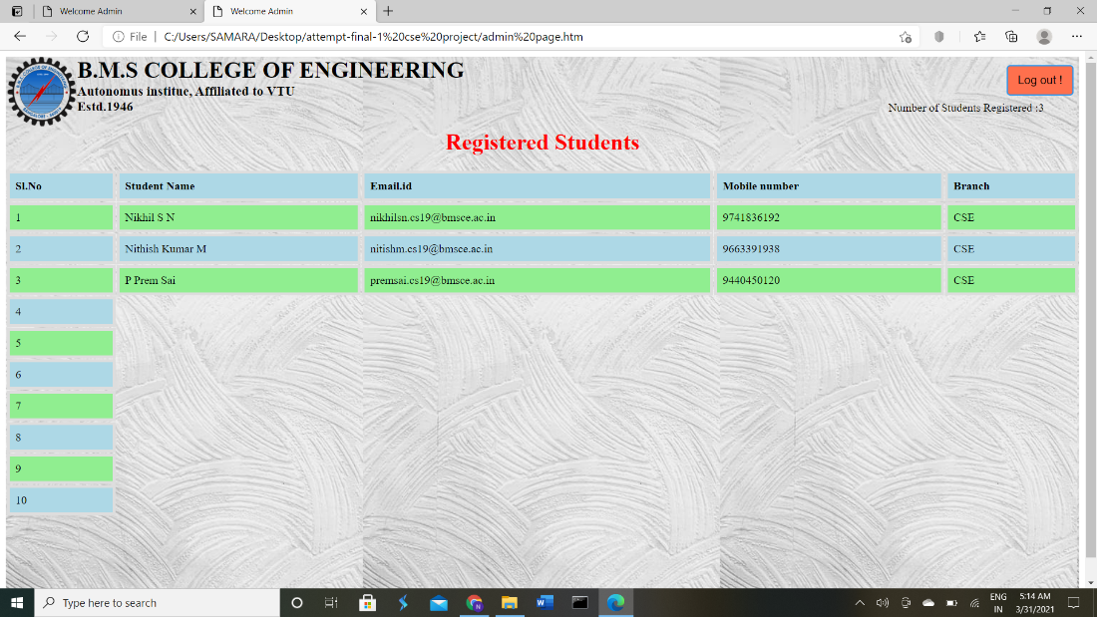

***THANK YOU***